⭐ 1. What is SQL Injection? (Simple + Slightly Elaborated)
SQL Injection is a trick where the attacker types special text into your input fields (like username, search box, login form) so that:
➡️ Your original SQL query breaks
➡️ A new SQL query gets created
➡️ The database does something unexpected or dangerous
In one line:
👉 SQL Injection happens when user input becomes part of SQL.

⭐ 2. Why does SQL Injection happen?
It happens because you write SQL like this:
String sql = "SELECT * FROM users WHERE username='" + userInput + "'";
Here:
- You allow user input to mix directly with SQL.
- Whatever the user types will become part of the SQL query.
- If user types harmful text, it becomes harmful SQL.
This is the core reason.

⭐ 3. Example That Shows the Problem Clearly
Suppose you ask for username.
A normal user types: pavan
But an attacker types:
pavan' OR '1'='1
Your final SQL becomes:
SELECT * FROM users WHERE username='pavan' OR '1'='1';
Why is this dangerous?
✔ '1'='1' is always true
✔ So the condition is always true
✔ The query returns all rows
✔ The attacker can log in without knowing password
✔ The attacker can see all user accounts
This is a classic SQL injection attack.

⭐ 4. What Serious Damage Can Happen?
With SQL injection, attackers can:
✔ Read sensitive data
✔ Modify data
✔ Delete rows
✔ Drop entire tables
✔ Bypass login
✔ Take full control of your database

⭐ 5. How to Stop SQL Injection?
The best way in JDBC is:
👉 Use PreparedStatement
(Instead of normal Statement)
Now let’s explain PreparedStatement properly, in simple words.

⭐ 6. What is PreparedStatement? (Simple Definition)
PreparedStatement is a safe version of SQL statement in JDBC.
Think of it like this:
➡️ SQL structure is fixed
➡️ User input goes into placeholders
➡️ Input is treated only as data, not SQL
PreparedStatement looks like this:
PreparedStatement ps = conn.prepareStatement(
"SELECT * FROM users WHERE username=?"
);
ps.setString(1, userInput);
The ? is like a blank box where you fill data later.

⭐ 8. How PreparedStatement avoids SQL Injection? (Super Simple Explanation)
Think of it like this:

❌ When you use Statement:
You combine SQL + user input into one string.
This is risky because:
➡️ If user types harmful text,
➡️ That harmful text becomes part of your SQL,
➡️ And the database executes that harmful SQL.
So attack is possible.

✅ When you use PreparedStatement:
SQL and input are kept separate.
SQL query is fixed like this:
SELECT * FROM users WHERE username=?
The ? is a safe box.
Whatever the user types goes inside that box only.
- It cannot change the SQL
- It cannot add new conditions
- It cannot break the query
- It is treated as normal text
Even if user types:
' OR '1'='1
PreparedStatement does NOT treat it as SQL.
It treats it like just a string (like someone typed a weird name).
So the query becomes safe:
username = "' OR '1'='1"
Not:
username='' OR '1'='1'

⭐ The simplest sentence to remember:
Statement mixes SQL and input → risky.
PreparedStatement separates SQL and input → safe.

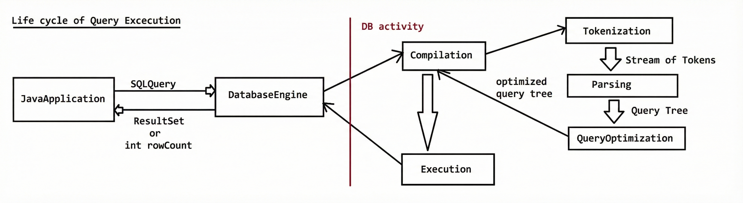

⭐ Life Cycle of Query Execution (Full Simple Explanation)

Step 0: Java Application
Your Java program creates an SQL query and sends it to the Database Engine.
Example:
SELECT * FROM users WHERE id=10;
Java → Database
This query travels to the database, and the database starts processing it.

⭐ Step 1: Compilation Phase
The database does three small checks before running the query.

1️⃣ Tokenization (Break into pieces)
The SQL query is split into small meaningful parts:
- SELECT

- FROM
- users
- WHERE
- id
- =
- 10
This helps the database understand the query.

2️⃣ Parsing (Check correctness)
The database verifies:
- Is the SQL syntax correct?
- Does the table exist?
- Do the columns exist?
- Is the query valid?
If anything is wrong → error.

3️⃣ Optimization (Find the best way to run it)
The database now decides:
- Which index to use
- How to fetch data in the fastest way
- Which internal operations are required
👉 Think of this as the database selecting the fastest route to reach the data, like Google Maps choosing the best path.
The output of this stage is an optimized query plan (also called query tree).

⭐ Step 2: Execution Phase
Now the database takes the optimized query plan and executes it.
This means:
- It goes to the correct table
- Reads the required rows
- Applies conditions (WHERE)
- Sorts or filters as needed
- Prepares the data to send back
👉 Execution is simply performing the actual work to get or modify the data.

⭐ Step 3: Result Phase
After execution is completed, the database sends the result back to Java.

If it is a SELECT query:
Java receives a ResultSet containing rows of data.

If it is INSERT, UPDATE, DELETE:
Java receives rowCount (how many rows changed).
Then Java program uses these results as needed.

⭐ Where PreparedStatement Helps (Simple English Explanation)

✔ PreparedStatement works before Step 1 (Compilation Phase)
When you write this:
PreparedStatement ps = conn.prepareStatement(
"SELECT * FROM users WHERE id=?"
);
The database compiles this SQL only once.
Meaning:
- Tokenization happens
- Parsing happens
- Optimization happens
👉 All these steps are done one time only.
This compiled plan is stored inside the database (or driver).
Later when you execute:
ps.setInt(1, 10);
ps.executeQuery();
OR with different values:
ps.setInt(1, 20);
ps.executeQuery();
The database does NOT recompile again.
It directly uses the pre-compiled optimized plan and executes quickly.

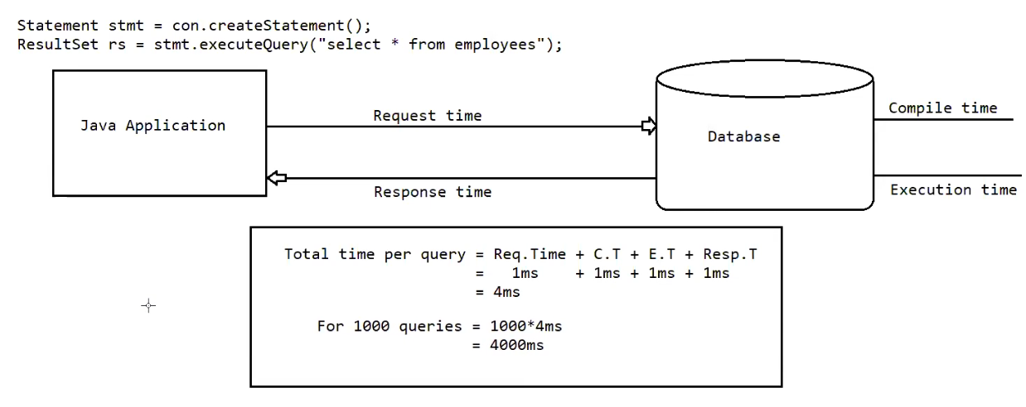

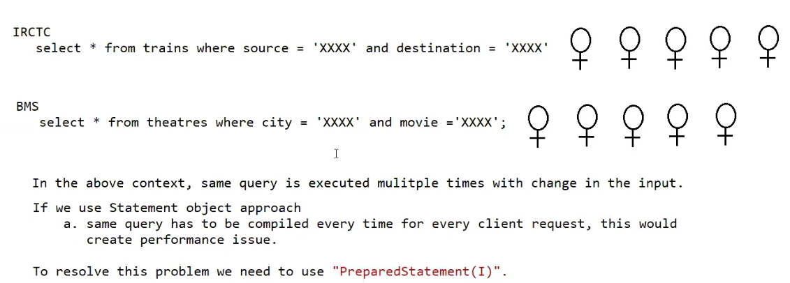

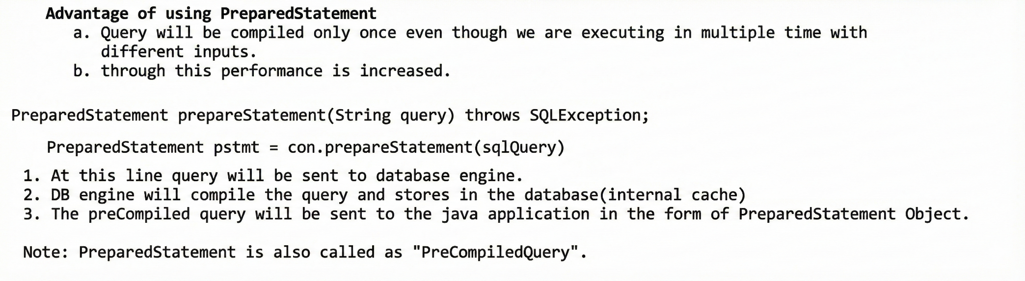

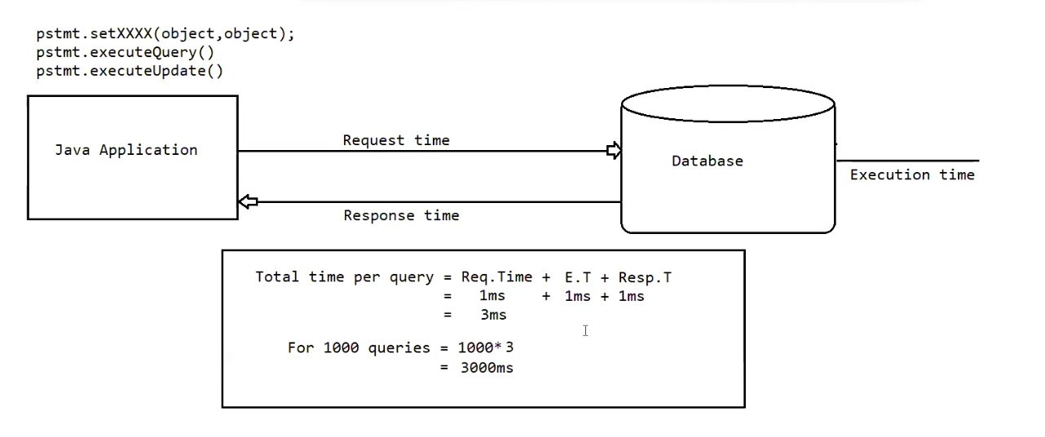

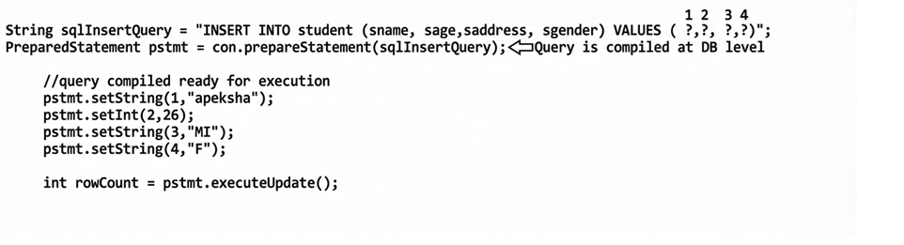

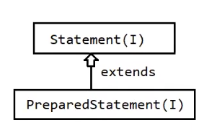

To use a resource inside try-with-resources, the resource must implement the AutoCloseable interface.

⭐ Why AutoCloseable?
Because Java must know how to close the resource automatically.
If a class implements AutoCloseable, Java understands:
resource.close(); // Java will call this automatically

⭐ Examples of classes that already implement AutoCloseable
Class | Implements AutoCloseable? | Can use in try-with-resources?
Connection | ✔️ Yes | ✔️ Yes
PreparedStatement | ✔️ Yes | ✔️ Yes
ResultSet | ✔️ Yes | ✔️ Yes
FileInputStream | ✔️ Yes | ✔️ Yes
Scanner | ✔️ Yes | ✔️ Yes
BufferedReader | ✔️ Yes | ✔️ Yes
So all these can be used directly.

⭐ Simple example
try (FileInputStream fis = new FileInputStream("data.txt")) {
// use fis
}
// fis auto closed
Behind the scenes Java calls:
fis.close();

⭐ Super Simple Explanation
✔️ To put something inside try-with-resources,
✔️ it must implement AutoCloseable,
✔️ so Java knows how to close it automatically.

⭐ What is try-with-resources?
It is a special try block in Java that automatically closes resources after the work is done.
A resource means any object that must be closed:
- Connection
- PreparedStatement
- ResultSet
- FileInputStream
- Scanner
These all have one common feature:
👉 They implement AutoCloseable interface.

⭐ Why do we need it?
Before Java 7, you had to close resources manually:
try {
Connection con = ...
PreparedStatement ps = ...
} catch(Exception e) {
e.printStackTrace();
} finally {
ps.close();
con.close();
}
This was long, messy, and if you forgot close(), memory leak or DB leak happens.

⭐ try-with-resources makes it super simple

✔️ Java closes the resource automatically
You do NOT write close().

✔️ Even if an exception happens, resource still closes

⭐ Syntax (Very Simple)
try (Resource r = new Resource()) {
// use the resource
}
Java automatically closes r after the try block ends.

⭐ JDBC Example without try-with-resources (OLD)
Connection con = null;
PreparedStatement ps = null;

try {
con = DriverManager.getConnection(...);
ps = con.prepareStatement(...);
ps.executeUpdate();
} finally {
ps.close();
con.close();
}

⭐ JDBC Example with try-with-resources (NEW, Professional)
try (Connection con = DriverManager.getConnection(...);
PreparedStatement ps = con.prepareStatement("INSERT ...")) {

ps.executeUpdate();
}
✔️ No need for manual closing
✔️ Cleaner
✔️ Professional style
✔️ No resource leaks

⭐ Simple Analogy (Very Easy)
Think of using a rented bike.

Old Way:
You rent the bike → ride it → but you must remember to return it.
If you forget, you get fined.

try-with-resources:
You rent the bike → ride it →
🚀 When time ends, the system automatically returns the bike for you.
You don’t have to remember.

Eg: Jdbc_Example_With_Prepared_Statement
//go through the code

Eg: Jdbc_Example_With_Prepared_Statement_Eg2
// go through the code

Eg: Jdbc_Example_With_Prepared_Statement_Eg3
// go through the code

✅ Advantages of PreparedStatement
(Polished + simple English)
- High performance
  - The query is compiled only once and reused.
  - This is faster than Statement, which compiles the query every time.
- Less network traffic
  - Only parameters change, the query itself is not re-sent repeatedly.
- Inputs can be given dynamically
  - You don’t need to put values in the query string.
  - You can supply inputs later using setXXX() methods.

4. Java-style input binding (no DB formatting needed)
When using PreparedStatement, you give values in normal Java format, like:
- Java String
- Java int
- Java double
- Java Date
You do NOT need to worry about:
- Quotes ' ' around strings
- Date format of the database
- Decimal format
- Escaping special characters

✔️ Example
ps.setString(1, "John");
ps.setInt(2, 25);
ps.setDouble(3, 55000.75);
You simply use Java values.
The PreparedStatement automatically converts them to the correct database format.
You don’t manually build the SQL string.

5. Best for inserting Date values
Different databases expect dates in different formats:
- MySQL → YYYY-MM-DD
- Oracle → DD-MON-YYYY
- PostgreSQL → YYYY-MM-DD HH:MM:SS
- SQL Server → varies
If you use Statement, you must manually convert the date to the database-specific format:
Example (hard):
"insert into emp values('2025-12-09')"
If the format is wrong → query fails.

✔️ PreparedStatement makes it super easy
You simply use:
ps.setDate(1, java.sql.Date.valueOf("2025-12-09"));
PreparedStatement internally:
- Converts the Java Date to the database’s expected Date format
- Avoids mistakes
- Avoids format mismatch errors

👉 You don’t need to know the database’s date format.
Java handles the conversion automatically.

6. Best for inserting BLOBs and CLOBs
Some data cannot be passed as normal text values.
Examples:
- Images (JPG, PNG)
- PDF files
- Audio files (MP3, WAV)
- Videos
- Large text files (articles, reports, documents)
These are stored in the database as:
- BLOB → Binary Large Object (binary data)
- CLOB → Character Large Object (large text)

⭐ Why PreparedStatement is best for this?

✔️ 1. It allows streaming large files
You can directly send a file into the query using:
ps.setBinaryStream(1, new FileInputStream("image.jpg"));
or
ps.setCharacterStream(1, new FileReader("largeTextFile.txt"));
Statement cannot handle this easily.

✔️ 2. No need to convert file into a string
If you try to insert a file using Statement,
you must convert it to text or encode it → very difficult.
PreparedStatement directly accepts:
- InputStream
- Reader
- byte[]
So it is simple and clean.

✔️ 3. Perfect handling of binary data
Binary files contain:
- special characters
- zeros
- bytes that break normal SQL strings
If you try to put them into a normal SQL query, the query breaks.
PreparedStatement sends binary data separately from the SQL command,
so no corruption happens.

✔️ 4. Works safely for very large files
Some files may be:
- 5 MB
- 50 MB
- 200 MB
PreparedStatement handles this smoothly because it streams the data to the database.

⭐ Simple Real-Life Example (easy to picture)

Suppose you want to store an employee’s photo.
With PreparedStatement:
PreparedStatement ps = con.prepareStatement(
"INSERT INTO employee(id, photo) VALUES(?, ?)"
);

ps.setInt(1, 101);
ps.setBinaryStream(2, new FileInputStream("photo.jpg"));
ps.executeUpdate();
✔️ Simple
✔️ No formatting
✔️ Works for all file types
7. Prevents SQL Injection
- Because query structure is fixed and inputs are treated as data, not code.

❌ Limitation of PreparedStatement
(Polished explanation)

With Statement
Statement stmt = connection.createStatement();
stmt.executeUpdate("insert into student values ...");
stmt.executeQuery("select * from student");
stmt.executeUpdate("delete from student where ...");
✔️ One Statement object can execute many different queries
✔️ Query text can be changed each time

With PreparedStatement
PreparedStatement pstmt = connection.prepareStatement("select * from student");
pstmt.executeQuery();
❌ One PreparedStatement is tied to only one query
✔️ You can execute that same query multiple times
✔️ You can change only the input values, not the SQL text
If you want a new SQL, you must create a new PreparedStatement.

✅ Which of the following are valid SQL with PreparedStatement?

Rule to remember:
👉 ? can ONLY replace input values.
It cannot replace table names, column names, or SQL keywords.
Now check each query:

1. delete from employee where ename = ? → VALID ✔️
- ? is used in place of a value → correct.

2. delete from employee ? ename = ? → INVALID ❌
- ? cannot replace keywords (like where).

3. delete from ? where ename = ? → INVALID ❌
- ? cannot replace table name (employee).

4. delete ? employees where ename = ? → INVALID ❌
- ? cannot replace SQL keywords (from).

✅ Final Note (Simple)
Use ? only for actual values, like:
- name
- age
- id
- department
Not for:
- table names
- column names
- SQL keywords
- operators

Static query vs Dynamic query
The sql query without positional parameter(?) is called static query.
eg: delete from employee where ename = 'sachin';
The sql query with positional parameter(?) is called dynamic query
eg: delete from employee where ename = ?
select eid,ename,esal from employee where esal > ?

Note:
Simple Statement object can be used for static queries, where as Preparedstatement object can be used for static queries and dynamic queries also.

⭐ Handling Date Values for Database Operations (Simple Explanation)
Sometimes in our programs we must insert or retrieve dates like:
- DOB → Date of Birth
- DOJ → Date of Joining
- DOM → Date of Manufacturing
- DOP → Date of Purchase
When working with dates and a database, using String values for dates is not recommended.

❌ Why not use String for dates?
Because:
- Comparing dates becomes difficult
- Sorting becomes inaccurate
- Date format differences cause errors
- Database may reject the value
So Java gives us special classes to handle dates properly.

⭐ Java has two Date classes

1️⃣ java.util.Date
- This is the general-purpose Date class.
- Used inside the Java application (normal Java code).
- Can represent both Date and Time.
Example: 2025-12-10 14:35:22
Use this when your Java program needs to work with date/time.

2️⃣ java.sql.Date
- This class is child of java.util.Date.
- Specially designed for database operations.
- Represents only Date, not time.
Example: 2025-12-10
Use this when sending dates to the database using PreparedStatement.

⭐ When to use which? (Very Simple Rule)
Purpose | Use
Work with date/time inside Java | java.util.Date
Send/receive Date values from database | java.sql.Date

⭐ Why do we need java.sql.Date?
Different databases expect dates in a special format (like YYYY-MM-DD).
When you use:
ps.setDate(1, java.sql.Date.valueOf("2025-12-10"));
Java automatically converts it to the format required by the database.
No formatting required by you.

⭐ Summary (Easy to remember)
- Never store dates as Strings → hard to compare and sort
- Use java.util.Date in normal Java logic
- Use java.sql.Date when interacting with database
- java.sql.Date → only Date
- java.util.Date → Date + Time

Eg: DateConversionExample

⭐ Why do we convert java.util.Date → milliseconds → java.sql.Date?
Because:

👉 java.sql.Date does NOT accept a java.util.Date directly.
It only accepts milliseconds.
Look at the constructor of java.sql.Date:
public Date(long date)
It takes long (milliseconds), not a util.Date object.
So you must convert like this:
long millis = utilDate.getTime();
java.sql.Date sqlDate = new java.sql.Date(millis);

⭐ Why can't we give util.Date directly?
Because they are two different classes designed for different purposes:

✔️ java.util.Date
- Represents date + time
- Used inside Java program

✔️ java.sql.Date
- Represents only date
- Used for database operations
- Requires milliseconds in constructor
So Java forces us to convert.

⭐ But why milliseconds?
Because that’s how Java internally represents a point in time:
- January 1, 1970 → starting point
- Every date/time is calculated as milliseconds from that point
So the easy way to convert from any Date is:
utilDate.getTime()
And using that, sql.Date constructs a date suitable for database use.

⭐ Simple Analogy
Think of:
- java.util.Date → an object with full details: (day, month, year, hour, minute, second)
- java.sql.Date → only date portion
To extract just the date part, Java asks for milliseconds, and sql.Date uses that to make a DB-friendly date.

⭐ Final Simple Answer (One Line)
You must convert java.util.Date to milliseconds because java.sql.Date only accepts milliseconds, not a util.Date object.

⭐ Why does new java.util.Date() already contain the date & time?
Because the constructor of java.util.Date automatically stores the current system date and time at the moment the object is created.
You don’t need to call any method because the constructor itself sets it.

⭐ What really happens internally?
When you write:
java.util.Date utilDate = new java.util.Date();
Internally Java does this:
- Reads the current system time in milliseconds
- Stores that value inside the Date object
- Converts that value into a human-readable date & time (when printed)
You don't see this code, but it happens automatically.

⭐ Proof from the actual constructor
If you check the source code of java.util.Date:
public Date() {
this(System.currentTimeMillis());
}
This means:

✔️ When you create new Date(),

→ Java calls System.currentTimeMillis()

→ That gives the current date & time

→ Stored inside the object
So the Date object is already filled with current time.

⭐ Why does System.out.println(utilDate) show a date?
Because the Date class has a toString() method that converts the stored milliseconds into a formatted date-time like:
Tue Dec 10 14:52:31 IST 2025
You don’t need to call it manually; print() calls it automatically.

Internally it is overridden like this ( just for a basic idea)
public String toString() {
// BaseCalendar and Date normalization
BaseCalendar.Date date = normalize();

StringBuilder sb = new StringBuilder(28);
int index = date.getDayOfWeek();
if (index == BaseCalendar.SUNDAY) {
index = 8;
}
convertToAbbr(sb, wtb[index]).append(' '); // Day name
convertToAbbr(sb, wtb[date.getMonth() - 1 + 1]).append(' '); // Month name
CalendarUtils.sprintf0d(sb, date.getDayOfMonth(), 2).append(' ');
CalendarUtils.sprintf0d(sb, date.getHours(), 2).append(':');
CalendarUtils.sprintf0d(sb, date.getMinutes(), 2).append(':');
CalendarUtils.sprintf0d(sb, date.getSeconds(), 2).append(' ');
sb.append(date.getYear());
return sb.toString();
}

⭐ Final Simple Answer
When you create:
new java.util.Date();
Java automatically:
✔️ Takes current system date & time
✔️ Stores it inside the object
✔️ So you don't need any method call

⭐ COMPLETE FLOW
new java.sql.Date(millis)
↓
Child constructor
↓
super(millis)
↓
Parent stores millis in fastTime
↓
(Wait… no conversion yet)
↓
System.out.println(sqlDate)
↓
toString() is called
↓
toString() internally triggers normalize()
↓
normalize() converts millis → date/time fields
↓
sql.Date.toString() picks only date fields
↓
Returns "yyyy-mm-dd"
↓
println prints it on screen

⭐ Flowchart With Code Snippets

✅ new java.sql.Date(millis)
java.sql.Date sqlDate = new java.sql.Date(millis);

✅ Child constructor
public Date(long date) {
super(date);
}

✅ super(millis)
super(millis);

✅ Parent stores millis in fastTime
public Date(long date) {
fastTime = date;
}

⚠️ (Wait… no conversion yet)
✔️ No code here — only storage
✔️ No normalize() yet

✅ System.out.println(sqlDate)
System.out.println(sqlDate);

✅ toString() is called
sqlDate.toString();

✅ toString() internally triggers normalize()
(inside java.util.Date's logic)
BaseCalendar.Date date = normalize();

✅ normalize() converts millis → date/time fields
(simplified internal code)
private BaseCalendar.Date normalize() {
// convert fastTime → year, month, day, hour, minute, second
}

✅ sql.Date.toString() picks only date fields
public String toString() {
return year + "-" + month + "-" + day;
}

✅ Returns "yyyy-mm-dd"
return "2025-12-08";

✅ println prints it on screen
2025-12-08

⭐ Flowchart With Code Snippets — java.sql.Time

✅ new java.sql.Time(millis)
java.sql.Time sqlTime = new java.sql.Time(millis);

✅ Child constructor (sql.Time)
public Time(long time) {
super(time);
}

✅ super(millis)
super(time);

✅ Parent stores millis in fastTime
public Date(long date) {
fastTime = date;
}

⚠️ (Wait… no conversion yet)
✔️ No conversion happens here
✔️ Only fastTime is stored

✅ System.out.println(sqlTime)
System.out.println(sqlTime);

✅ toString() is called
sqlTime.toString();

✅ toString() internally triggers normalize()
(inside java.util.Date logic)
BaseCalendar.Date date = normalize();

✅ normalize() converts millis → date/time fields
(simplified internal code)
private BaseCalendar.Date normalize() {
// convert fastTime → year, month, day, hour, minute, second
}

✅ sql.Time.toString() picks ONLY time fields
public String toString() {
// returns hh:mm:ss
}

✅ Returns "HH:MM:SS"
Example:
return "14:25:36";

✅ println prints it on screen
sql.Time : 14:25:36

⭐ Flowchart With Code Snippets — java.sql.Timestamp

✅ new java.sql.Timestamp(millis)
java.sql.Timestamp sqlTimestamp = new java.sql.Timestamp(millis);

✅ Child constructor (sql.Timestamp)
public Timestamp(long time) {
super(time);
nanos = (int)((time % 1000) * 1000000);
}
(Timestamp stores millis in parent AND calculates nanoseconds)

✅ super(millis)
super(time);

✅ Parent stores millis in fastTime
public Date(long date) {
fastTime = date;
}

⚠️ (Wait… no conversion yet)
✔️ Only storage in fastTime
✔️ normalize() not executed yet

✅ System.out.println(sqlTimestamp)
System.out.println(sqlTimestamp);

✅ toString() is called
sqlTimestamp.toString();

✅ toString() internally triggers normalize()
(inside java.util.Date logic)
BaseCalendar.Date date = normalize();

✅ normalize() converts millis → date/time fields
(simplified internal code)
private BaseCalendar.Date normalize() {
// convert fastTime → year, month, day, hour, minute, second
}

✅ sql.Timestamp.toString() picks date + time + nanos
public String toString() {
// returns yyyy-mm-dd hh:mm:ss.nnnnnnnnn
}

✅ Returns "YYYY-MM-DD HH:MM:SS.NNNNNNNNN"
Example:
return "2025-12-08 14:25:36.123000000";

✅ println prints it on screen
2025-12-08 14:25:36.123000000

util Date : Mon Mar 20 19:07:29 IST 2017
sql Date : 2017-03-20
⭐ Differences between java.util.Date and java.sql.Date (Simple & Clear)
✅ java.util.Date
It is a general utility class in Java used to work with dates in normal Java programs.
It represents both Date and Time.
Example output: Mon Mar 20 19:07:29 IST 2017

✅ java.sql.Date
It is specially designed for use with Database operations (JDBC).
It represents only Date, not Time.
Example output: 2017-03-20

⭐ Additional Note
In the java.sql package:
Time class → represents only Time
Timestamp class → represents Date + Time + Nanoseconds
This is why JDBC uses three separate classes:
java.sql.Date → Date only
java.sql.Time → Time only
java.sql.Timestamp → Date + Time (accurate for DB)

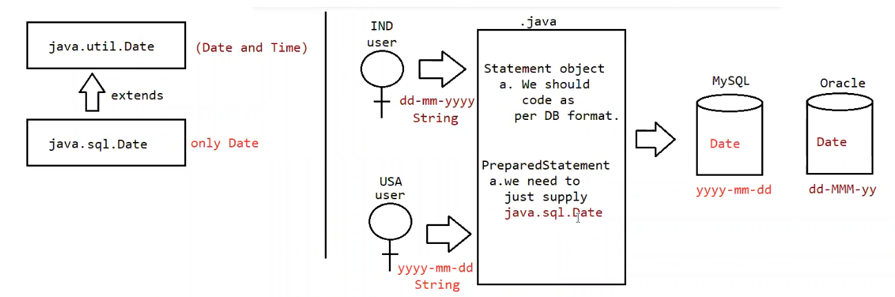

⭐ 1. Inheritance Concept (Left Side of Diagram)
java.util.Date ← (parent: Date + Time)
↑
extends
↓
java.sql.Date (child: Date only)

Meaning:
- java.util.Date → stores date + time
- java.sql.Date → stores only date
(because databases expect only date for DATE column)
The child class (sql.Date) extends the parent (util.Date),
but hides the time part when printing or sending to the DB.

⭐ 2. Different Users Give Different Date Formats (Middle of Diagram)

IND user
Format: dd-MM-yyyy
Example: 20-03-2017
Type: String

USA user
Format: yyyy-MM-dd
Example: 2017-03-20
Type: String
Different users → Different date formats → Different string inputs.

⭐ 3. Statement vs PreparedStatement (Center Box)
The diagram shows:

✔️ Statement
You must manually convert the user's String into the database format
because Statement only takes Strings, not Date objects.
Statement object
a. We should code as per DB format.
That means:
- If MySQL format is yyyy-MM-dd
- And user gives 20-03-2017
→ You must manually convert it to 2017-03-20
This is extra work for the programmer.

✔️ PreparedStatement
No need to manually format the date.
PreparedStatement knows how to handle dates automatically.
a. we need to just supply java.sql.Date
You simply give:
ps.setDate(1, sqlDate);
And PreparedStatement sends the correct format to the database.

⭐ 4. Database Format Differences (Right Side of Diagram)
Different databases store the DATE column in different internal formats:

MySQL
yyyy-MM-dd

Oracle
dd-MMM-yy
Example:
- 20-MAR-17

But YOU don’t have to format it manually
Because java.sql.Date + PreparedStatement handles everything for you.

⭐ 5. The Entire Diagram Meaning (Simple Summary)
The whole diagram explains ONE THING:
Different users give dates in different formats.
Different databases store dates in different formats.
java.sql.Date + PreparedStatement remove this problem.
So:
- Take user date string
- Convert it once into java.sql.Date
- Give it to PreparedStatement
- JDBC automatically applies the correct DB format

⭐ 6. 10-Second Memory Version
- util.Date → date + time
- sql.Date → only date
- Users input date as Strings (different formats)
- Databases store date in different formats
- PreparedStatement + java.sql.Date → automatic format handling

Eg: Convert_String_To_Sql_Date

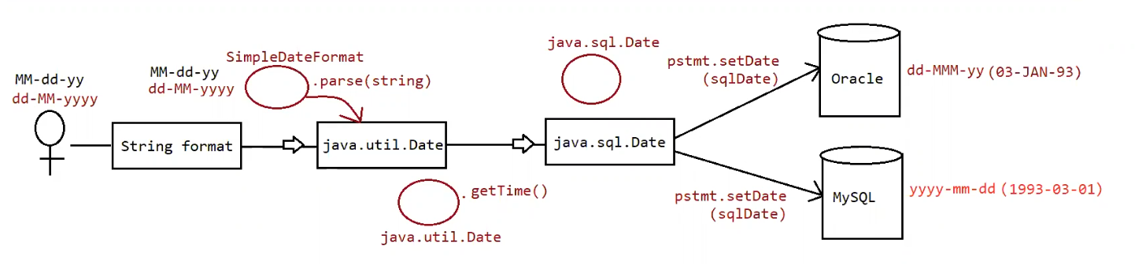

⭐ INTERNAL FLOW NOTES — SimpleDateFormat (WITH CONSTRUCTOR CODE)

🔹 STEP 1: User provides FORMAT STRING to constructor
SimpleDateFormat sdf = new SimpleDateFormat("dd-MM-yyyy");

Meaning:
- User (developer) gives a date FORMAT, not a date value
- This String tells how future dates should look
Example:
"dd-MM-yyyy" → 08-12-2025

🔹 STEP 2: JVM creates SimpleDateFormat object
Before constructor executes, JVM allocates memory:
pattern = null
calendar = null
numberFormat = null
lenient = true (default)
No logic yet. Just memory allocation.

🔹 STEP 3: Constructor is entered

Internal constructor (simplified JDK structure):
public SimpleDateFormat(String pattern) {
this.pattern = pattern;
initializeCalendar();
initializeNumberFormat();
}
Now step-by-step inside constructor 👇

🔹 STEP 4: Pattern is stored in instance variable
this.pattern = pattern;

What happens here:
- Method parameter pattern = "dd-MM-yyyy"
- Instance variable this.pattern stores it
📌 After this line:
this.pattern = "dd-MM-yyyy"

Important:
- This is NOT a date
- This is only a rule / instruction
- No parsing happens here

🔹 STEP 5: Pattern SYNTAX validation (NOT date validation)
Internally Java checks pattern correctness:
private void validatePattern() {
// checks for valid pattern letters
}

What is checked:
✔ Valid letters (d, M, y)
✔ Unsupported letters rejected
Example:
"dd-MM-xxxx" → ❌ IllegalArgumentException

What is NOT checked:
❌ Day/month values
❌ Leap year
❌ Any real date

🔹 STEP 6: GregorianCalendar is created
Inside constructor:
this.calendar = new GregorianCalendar();

What this does:
- Creates a date calculation engine
- Loads:
  - current year
  - current month
  - current day
  - current time
  - system timezone
📌 This data is temporary and will be overwritten later.

🔹 STEP 7: NumberFormat is created
Inside constructor:
this.numberFormat = NumberFormat.getIntegerInstance();

Purpose:
- Convert numeric text → integer
- Needed later during parsing
Example conversions (later):
"08" → 8
"12" → 12
"2025" → 2025
📌 No conversion happens now — only preparation.

🔹 STEP 8: Lenient mode is initialized
Inside constructor:
this.lenient = true;
this.calendar.setLenient(true);

Meaning:
- Java is allowed to auto-correct invalid dates
- This is just a rule, not execution
Examples (later during parse):
32-01-2025 → auto-adjust
If user later writes:
sdf.setLenient(false);
Then strict validation will apply.

🔹 STEP 9: Constructor ENDS

Object state after constructor:
SimpleDateFormat sdf
--------------------
pattern = "dd-MM-yyyy"
calendar = GregorianCalendar (ready)
numberFormat = IntegerNumberFormat (ready)
lenient = true
📌 Up to this point:
❌ No input date processed
❌ No validation performed
❌ No Date object created

🔹 STEP 10: User provides ACTUAL DATE STRING
String inputDate = scanner.next(); // "08-12-2025"

Important:
- This is the real date value
- Comes from user / program
- SimpleDateFormat has not used it yet

🔹 STEP 11: parse() is called (EXECUTION START)
Date date = sdf.parse(inputDate);
🔥 This line activates everything prepared earlier.

🔹 STEP 12: Pattern is USED (not stored)
Internal logic (simplified):
for(each pattern symbol) {
read matching input characters;
}

Pattern guides:
dd → read 2 digits (day)
MM → read 2 digits (month)
yyyy → read 4 digits (year)

🔹 STEP 13: NumberFormat is TRIGGERED
When digits are read:
int value = numberFormat.parse(textDigits);
Examples:
"08" → 8
"12" → 12
"2025" → 2025

🔹 STEP 14: Calendar is FILLED
calendar.set(DAY_OF_MONTH, 8);
calendar.set(MONTH, 11); // 0-based
calendar.set(YEAR, 2025);
Temporary current-date values are overwritten.

🔹 STEP 15: Lenient validation is APPLIED
calendar.isLenient();
- true → auto-correct
- false → throw ParseException

🔹 STEP 16: Calendar converts to milliseconds
long millis = calendar.getTimeInMillis();
Date math happens here.

🔹 STEP 17: Date object is created
return new Date(millis);
Final result:
java.util.Date

the remaining flow we had seen earlier i.e from util.Date to sql.Date

🔁 COMPLETE FLOW SUMMARY (FINAL)
User gives FORMAT → constructor stores pattern
Constructor prepares calendar, numberFormat, lenient
User gives DATE STRING
parse() is called
Pattern reads structure
NumberFormat converts digits
Calendar stores fields
Lenient validates
Calendar computes millis
Date object created

⭐ FINAL MEMORY STATEMENT (BEST)
Constructor = preparation
parse() = execution

📌 Single Responsibility Principle (SRP)

Who gave this principle?
👉 Robert C. Martin
(also known as Uncle Bob)

What is Single Responsibility Principle?
A class should have only ONE reason to change.
In simple English:
One class should do only ONE job.

Why SRP is important?
- Makes code easy to understand
- Makes code easy to maintain
- Reduces bugs
- Changes in one feature do not break others

How java.util.Date violated SRP
java.util.Date tried to handle:
- Date
- Time
- Timezone
- Database mapping
- Logging timestamp
👉 Multiple responsibilities in one class ❌
👉 SRP violated

One-line conclusion (perfect for notes)
java.util.Date violates the Single Responsibility Principle because it tries to represent multiple time-related concepts in a single class.

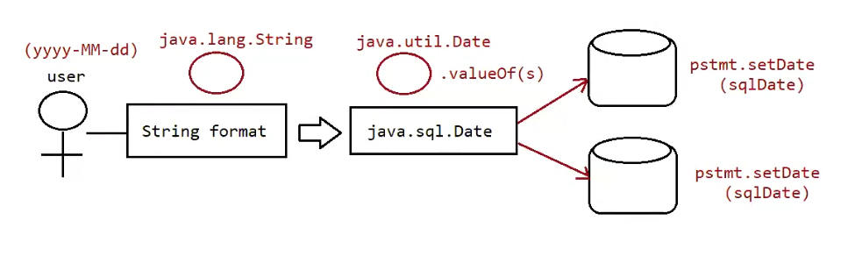

Eg : Jdbc_Convert_String_To_Sql_Date
// go through the code

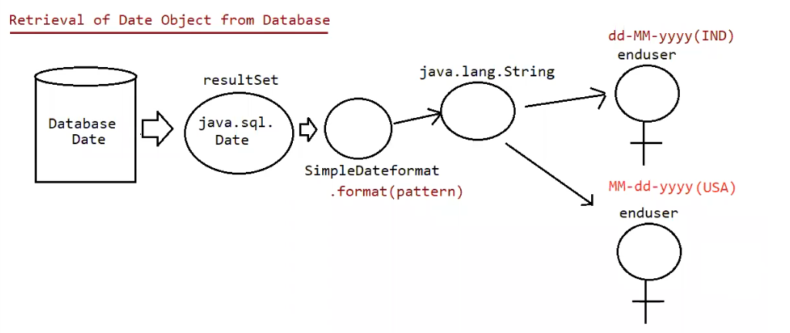
Retrieving Date value from the database
=> For this we can use either simple Statement or PreparedStatement.
=> The retrieved Date values are Stored in ResultSet in the form of "java.sql.Date" and we can get this value by using getDate() method.
=> Once we got java.sql.Date object, we can format into our required form by using
SimpleDateFormat object.

Sequence

1. Database
(java.sql.Date)sqldate = rs.getDate(2);

2. Our required String Form
String s = sdf.format(sqldate);

3. String s holds the date.
Eg: Jdbc_Convert_Sql_Date_To_String

Working with Large Objects (BLOB And CLOB)
Sometimes as the part of programming requirement, we have to insert and retrieve large files like images, video files, audio files, resume etc w.r.t database.
Eg: upload image in matrinomial web sites
I upload resume in job related web sites

To store and retrieve large information we should go for Large Objects (LOBs).
There are 2 types of Large Objects.
1. Binary Large Object (BLOB)
2. Character Large Object (CLOB)
1) Binary Large Object (BLOB)
A BLOB is a collection of binary data stored as a single entity in the database.
BLOB type objects can be images, video files, audio files etc.
BLOB datatype can store maximum of "4GB" binary data.

2) CLOB (Character Large Objects):
A CLOB is a collection of Character data stored as a single entity in the database.
CLOB can be used to store large text documents (mainly plain text or xml documents)
CLOB Type can store maximum of 4GB data.
Eg: resume.txt

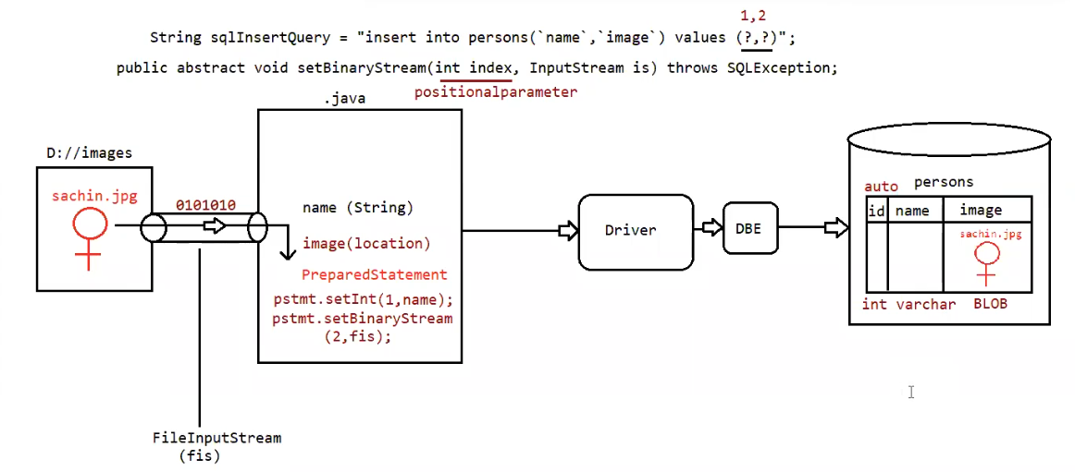

Eg: Jdbc_Image_Insertion

Steps to insert BLOB type into database:

1. create a table in the database which can accept BLOB type data.
create table persons (name varchar2(10), image BLOB);
2. Represent image file in the form of Java File object.
File f = new File("sachin.jpg");
3. Create FilelnputStream to read binary data represented by image file
FilelnputStream fis = new FilelnputStream(f)
4. Create PreparedStatement with insert query.
PreparedStatement pst = con.prepareStatement("insert into persons values(?,?)");
5. Set values to positional parameters.
pst.setString(1,"katrina");
To set values to BLOB datatype, we can use the following method: setBinaryStream()
public void setBinaryStream(int index,InputStream is)
public void setBinaryStream(int index,InputStream is,int length)
public void setBinaryStream(int index,InputStream is,long length)
6. execute sql query
pst.executeUpdate();

